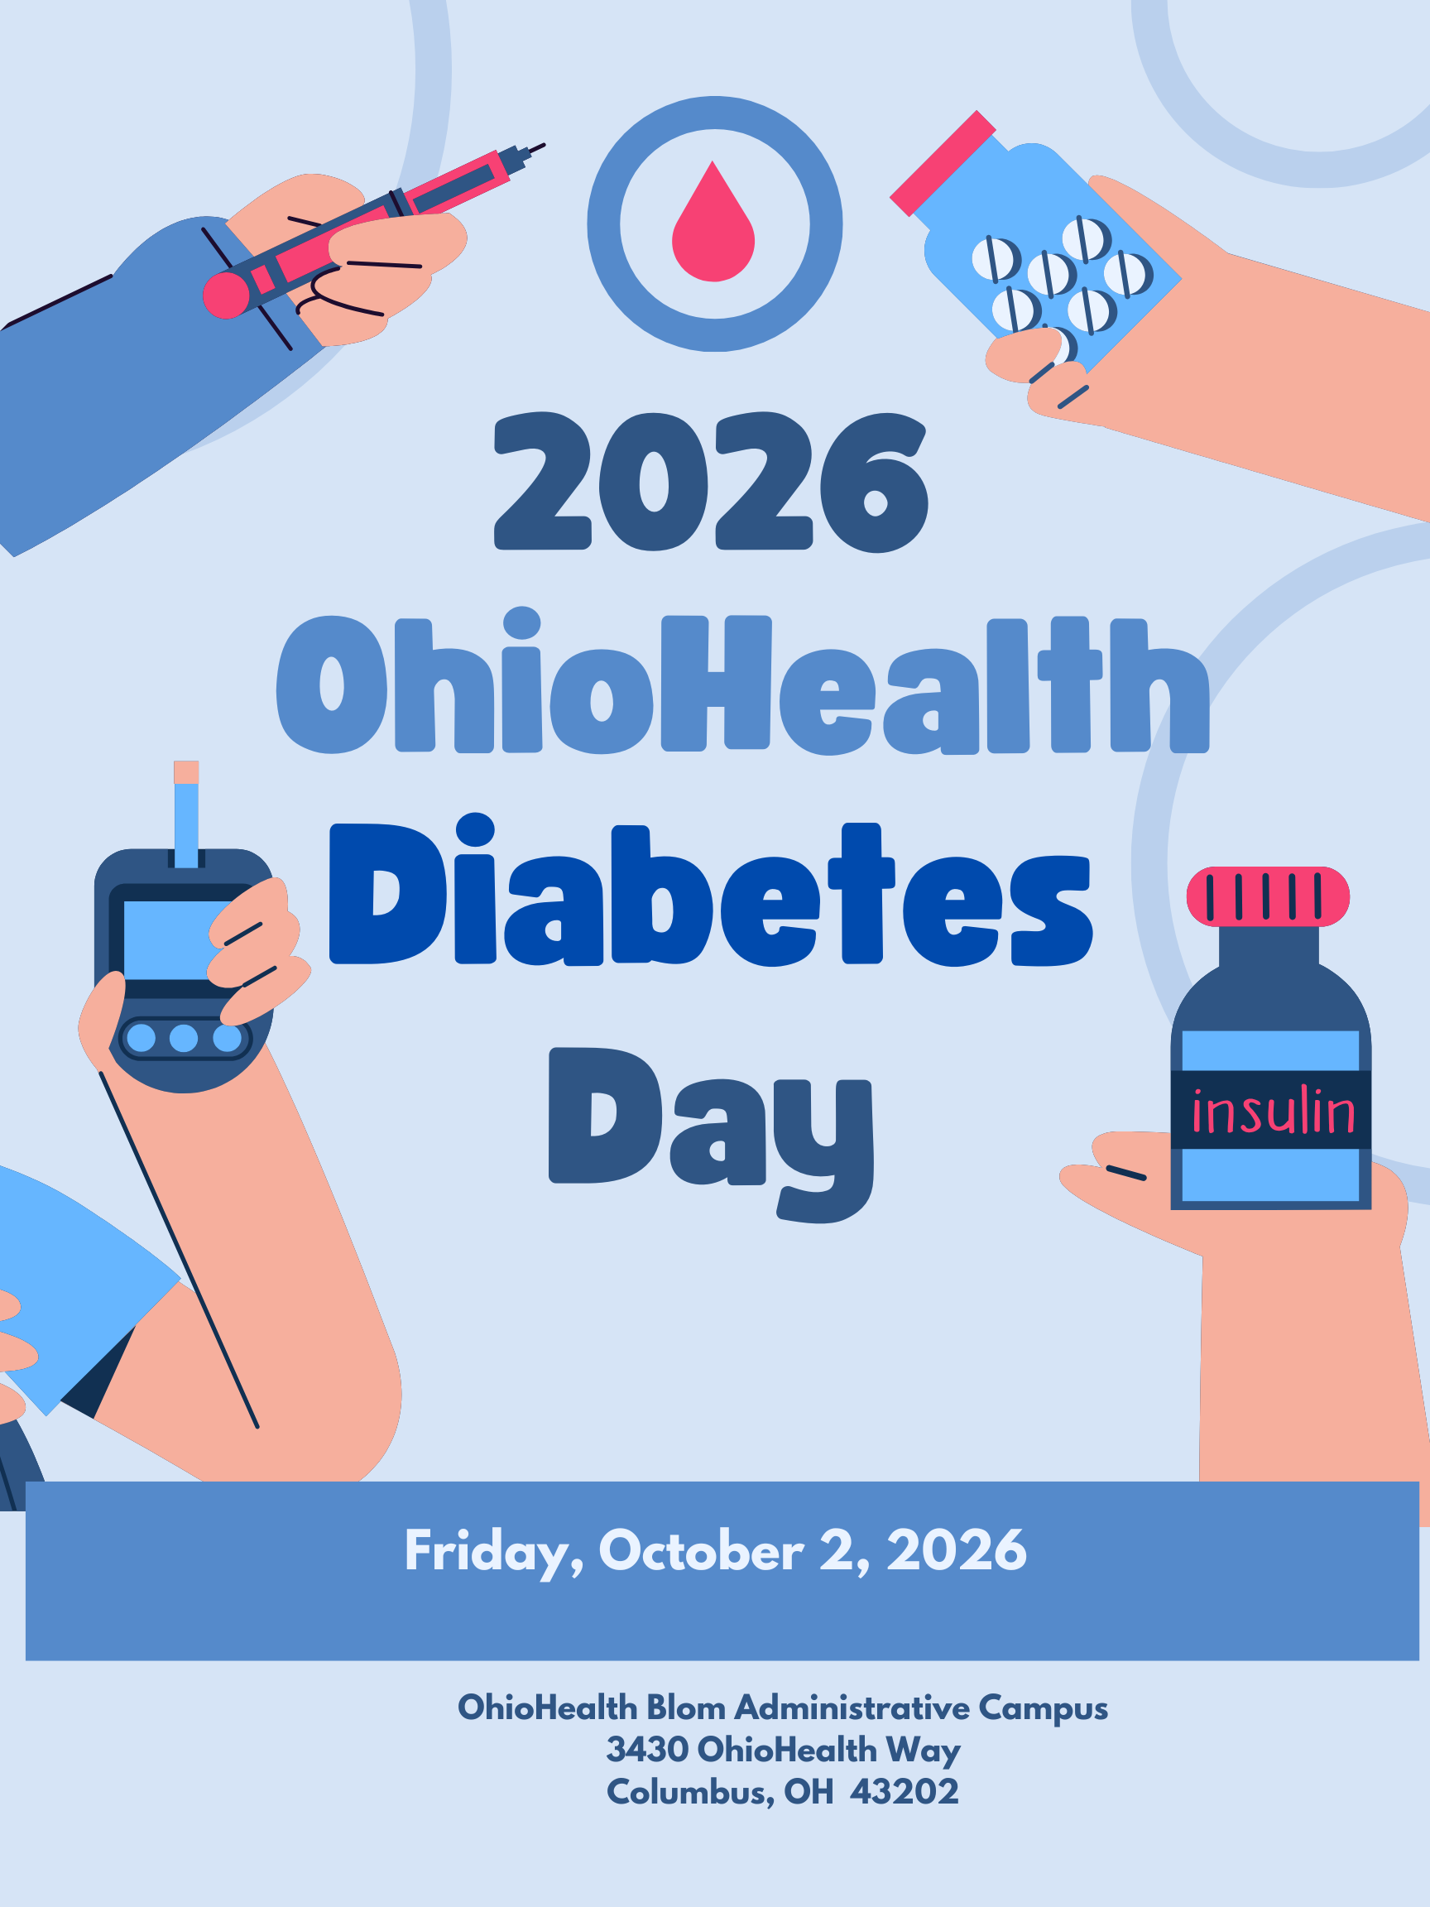
This event is made possible through a generous donation from the George W. and Elizabeth W Kelly Foundation.

Conference Description
We welcome you to join us for OhioHealth’s 2026 Annual Diabetes Day event. The goal of the event is to raise diabetes awareness and expand knowledge of the management of diabetes and associated conditions. This conference is designated for physicians, advanced practice providers, pharmacists, nurses, and diabetic educators who assess, treat, and provide care to diabetic patients.

Objectives
After the completion of this activity, participants will be able to:
+ Understand current research into cardiometabolic conditions.
+ Understand the work that is being done to address Health Equity in patients with diabetes.
+ Understand how heart failure and diabetes interact.
+ Understand how CGMs can help improve A1c.

General Information
Pricing
Thanks to the Kelly Foundation a portion of registration fees have been covered for all attendees.

Physicians: $75
Advanced Practice Providers: $50
Diabetic Educators, Pharmacists, Residents, and Other Healthcare Providers: Free
Vendors / Exhibitors $750

Registration
Register on or before September 15, 2026
Register Online at: 2026 Diabetes Day Registration

Cancellation and Refund Policy
OhioHealth reserves the right to cancel or delay this course due to unforeseen circumstances. In the event this activity is canceled, OhioHealth will refund your registration fee. We are not responsible for any travel, hotel or other costs incurred.

If a participant cancels, a refund of the registration fee, minus a 25% administrative charge, will be issued if written notice of cancellation is received no later than September 20, 2026. No refunds will be granted after September 20, 2026.

Faculty
Jon Blackman, MD
Endocrinology (Retired)
OhioHealth

Shrikant Tamhane, MD
Endocrinology
OhioHealth

Andrew Faiella, PharmD, BCACP
Pharmacy
OhioHealth

Jill Fulk, RDN, LD, CDCES
Diabetes Education
OhioHealth

Sherri Sprang, MSN, RN, NE-BC
Heart & Vascular, Prevention & Wellness
OhioHealth

Jay Patel, MD
Endocrinology
OhioHealth

Brianna Stevens, CNP
Endocrinology
OhioHealth

Anup Basuray, MD
Heart Failure
OhioHealth

Conference Agenda

7:30 – 8:30 a.m. | REGISTRATION, BREAKFAST, AND VENDOR NETWORKING BINGO – 60 MINUTES
8:30 – 8:45 a.m. | Opening Remarks ‖ Shrikant Tamhane, MD
8:45 – 9:30 a.m. | 2026 AHA Cardio-Kidney-Metabolic Guidelines ‖ Shrikant Tamhane, MD
9:30 – 10:15 a.m. | Health Equity: Strategies to Advance Performance in Diabetes Management ‖ Sherri Sprang, MSN, RN, NE-BC
 | Review the work that OhioHealth has been doing to address inequities in healthcare for patients with diabetes in underserved areas.
10:15 – 10:35 a.m. | BREAK AND VENDOR NETWORKING BINGO – 20 MINUTES
10:35 – 11:20 a.m. | CGM Cases / SGLT2 & GLP1 pearls ‖ Andrew Faiella, PharmD, BCACP
11:20 – 12:05 p.m. | Using CGM to Help Improve A1c ‖ Jay Patel, MD
 | Review how CGMs are helping patients manage their A1c.
12:05 – 1:05 p.m. | LUNCH AND VENDOR NETWORKING BINGO – 60 MINUTES
1:05 – 1:50 p.m. | Insulin Pumps Therapy: Comparing Current Technologies and Clinical Applications ‖ Brianna Stevens, CNP
 | Review the guidelines on how to manage lipid disorders.
1:50 – 2:35 p.m. | Heart Failure and Diabetes ‖ Anup Basuray, MD
 | Review how heart failure impacts patients with diabetes. Learn about clinical considerations in regards to treatment.
2:35 – 2:50 p.m. | Tips for Getting Prior Authorization for Diabetes Medications ‖ Beth Mason, RN
 | Discuss tips and suggestions for obtaining prior authorizations for various diabetes medications.
2:50 – 3:00 pm | CLOSING REMARKS AND PRIZE DRAWING

Accreditation
AMA OhioHealth is accredited by the Ohio State Medical Association (OSMA) to provide continuing medical education to physicians.

OhioHealth designates this live activity for a maximum of 5.0 AMA PRA Category 1 Credit(s)™. Physicians should claim only the credit commensurate with the extent of their participation in the activity.

OBN The Ohio Board of Nursing recognizes accepts a CE activity that has been approved by an agency that regulates a healthcare profession or discipline in Ohio or another jurisdiction. CME approved by the Ohio State Medical Association meets Ohio Board of Nursing CE requirements for nursing licensure.

Disclosure
As an accredited CME provider, OhioHealth must ensure balance, independence, objectivity, and scientific rigor in all sponsored activities. Faculty and planners participating in sponsored activities must disclose all financial relationships with any ineligible company or commercial interest. All conflicts of interest are reviewed for relevancy and mitigated prior to the activity and disclosed to the learners before the activity begins.

Commercial Support
This activity is not supported by any ineligible company or commercial interest.

